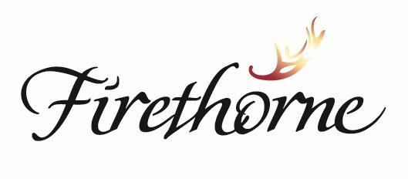

**Community Association, Inc.**

**NOTICE OF MEETING OF BOARD OF DIRECTORS**

DATE: June 26, 2024

TO: Robin Short, President

Katie Carner, Vice President

Cory Rivenburgh, Secretary

Ronald Crasta, Treasurer

Gary Boostrom, Board Member

From: Manny Lugo, Community Manager and Kathleen Oakley, Assistant Community Manager

This memorandum is official notice and agenda for a meeting of the Board of Directors of Firethorne Community Association, Inc. to be held on:

**DATE: Wednesday, June 26, 2024**

**LOCATION: TEAMS & S Firethorne Clubhouse**

**28800 S. Firethorne Road**

**TIME: 7:00PM**

**AGENDA**

* 1. Review October 22, 2020 meeting minutes.

1. Call to Order
   1. Establish Quorum
2. Community Input: Residents are welcome to address the Board of Directors on any issue pertinent to Firethorne Community Association business. Comments are limited to three (3) minutes per speaker and no more than ten (10) speakers. Multiple speakers may be allowed on a single subject at the Boards discretion but the Board requests that one speaker summarize for the group. The Board of Directors is not required to answer questions, engage in dialogue, or take any action regarding matters addressed by speakers during the meeting. The Board of Directors may or may not consider action at a future date.
3. Approve Minutes
4. Deputy Report
5. Financials for May
6. Committee Reports
   1. Amenities Committee
   2. Modifications Committee
   3. Cell Tower Exploratory Committee
   4. Community Watch Committee
   5. Special Events Committee
   6. Firethorne Firefish Swim Team
7. Manager’s Report
   1. Manager’s Recap of the Month Report

1. Old Business
   1. Appropriation of Funds to Reserves
   2. The Reserve at Katy (Drill site landscaping update)
2. New Business
   1. Perimeter Fence Update Phase 1 & 2, including change order
   2. Pool RFP
   3. Landscaping RFP
   4. Email address for Modification Chair
   5. Discuss Boulder or Bollard installation
   6. Update on Insurance Claim
   7. Development of an Action List
   8. TV Provider of the Fitness Center
   9. Street Cleaning
   10. Side Entry Gates at Gated Sections
   11. Amenities Policies/Reservation System on TownSq
   12. Election Site Request
   13. Cleaning Service Rate Increase Request
   14. Funds Transfer
   15. Pool Maintenance Issues & Additional Cleaning Day
   16. Little Free Library Repairs- Resident Reimbursement Request
   17. Associa Operating Procedures including CAM & Branch Staff
   18. Payment plan approval schedule
   19. Firethorne survey Report May 22, 2024
   20. Next Board Meeting TBD

1. Executive Session: All residents will be placed in the waiting room.

Discuss legal matters, personnel matters, Board procedures and other association matters.

1. Open Session
2. Adjourn